

UTCN-Wiki

Student: Marasescu-Duran Antonio

Group: 30431

# Vision

## Introduction

UTCN-Wiki is a Wikipedia-like website which will offer students at the Technical University of Cluj-Napoca educational resources.

## Positioning

The problem that this project is aiming to solve is the lack of centralized student-resources at our University. This will be solved by creating an online-repository which will contain online-materials (YouTube tutorials, useful links) and student-made resources (exam examples, solved problems, hints etc.). Moreover, the project is also aiming to achieve a community which will grow each year and will offer their input regarding professors and courses through comments and ratings.

## Stakeholders

The stakeholders for our product are the students at Technical University of Cluj-Napoca. Moreover, there will also be a special class of users called moderators which will take control which information is posted on the website.

# Use Case Model

## Specification

|  |  |
| --- | --- |
| **Goal** | Search for an UTCN-Course and download its resources |
| **Actor** | User |
| **Success Scenario** | The user will search for the course name, several related-links will appear, the user will click the most relevant one and the course page containing the required information will appear. From there, the user can select any resource it wants to download and press the download button. A download popup will appear and the user obtains said resource. |
| **Extension** | * The course name is not found an error will appear on the website. * If the user is not logged in and tries to access the course webpage, he will be redirected to the login page. |

|  |  |
| --- | --- |
| **Goal** | Approving a resource |
| **Actor** | Moderator |
| **Success Scenario** | The moderator can query for all upload requests that exists, select one from the list, see its content and choose whether is approved or not. |
| **Extension** | * If the moderator is not logged in and tries to access the course webpage, he will be redirected to the login page. |

|  |  |
| --- | --- |
| **Goal** | Banning a user |
| **Actor** | Moderator |
| **Success Scenario** | The moderator will enter the admin page and select the user it wants to ban and perform the task. |
| **Extension** | * If the moderator is not logged in and tries to access the admin webpage, he will be redirected to the admin login page. |

|  |  |
| --- | --- |
| **Goal** | Uploading a Resource for a course |
| **Actor** | User |
| **Success Scenario** | The user will search for the course name, several related-links will appear, the user will click the most relevant one and the course page containing the required information will appear. The user is on the course website and will select the upload button, the user will be redirected to the upload page and will fill the necessary information. The resource will not be visible until a moderator approves it. |
| **Extension** | * The resources are not approved; therefore, it will be removed from the server. * If the user is not logged in and tries to access the course webpage, he will be redirected to the login page. |

## Diagram

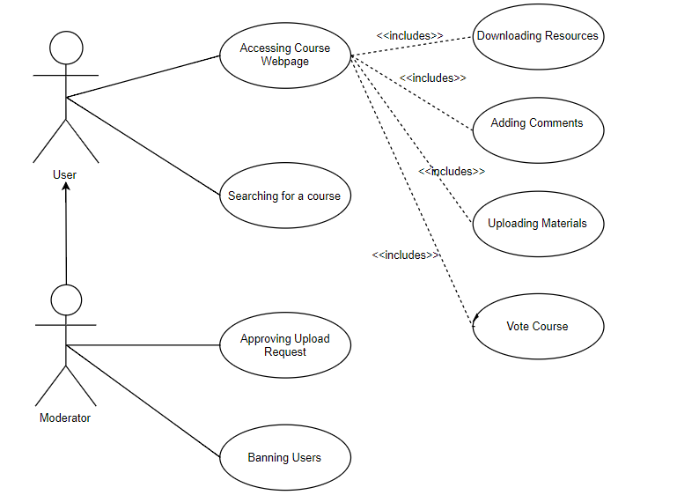

# Supplementary Specification

## Non-functional Requirements

Each user will have to register and login to access the website. The registration is done through a special invite code which can only be generated by another user.

## Design Constraints

The project will be implemented using Django and React.

# Glossary

Resource = solved problems/exams or any kind of material related to that course